**Setup System**

1. Server side.

- Open the folder ‘Backend’

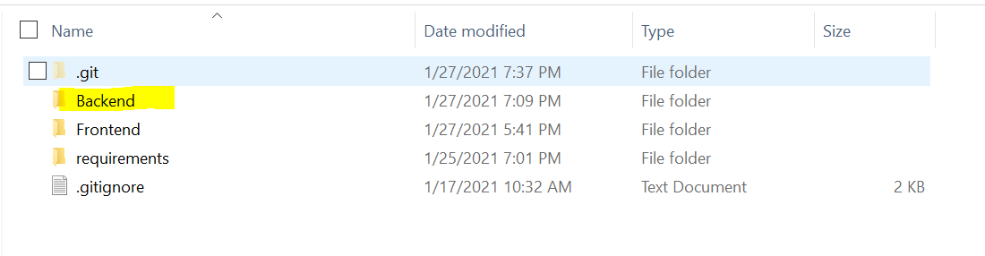

- Open file HealthInsuranceWebServer.sln



* Tool -> Nuget package manager -> Package manager console , then run the command below



* Run the command below



* Start server

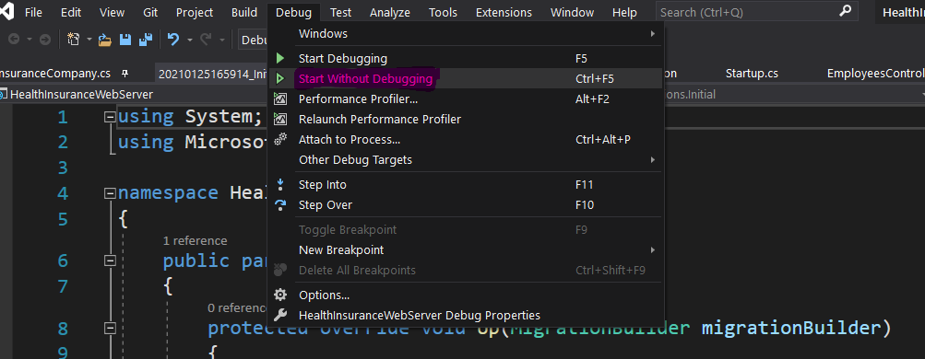

2. Client Side

- Open folder “Frontend” with Visual studio code



* Run -> New Terminal

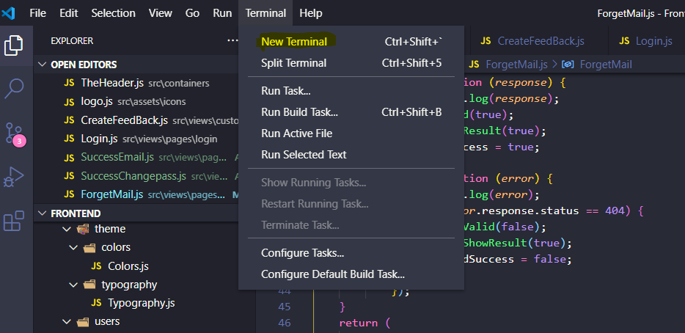

* Installs node module



* After installs node module success



* After start client

